

**Assignment-2**

**Course Title:- System Analysis & Design**

**Course Code :- CSE-325**

**Assign. Name:- Generalization & Association.**

**Submitted By:**

**Name :- Sheuly Das**

**ID :- 171442596**

**Program :- CSE(Evn)_44th Batch**

**Submitted To:**

**Instructor Info :-**

**Supta Richard Philip**

**(Senior Lecturer, Dept of CSE)**

Contents

Generalization 3

Fig .1 : Diagram of Generalization 3

Association 4

Fig .2 : Diagram of Association 4

## Generalization

Generalization is the process of extracting shared characteristics from two or more classes, and combining them into a generalized superclass. Shared characteristics can be attributes, associations, or methods.

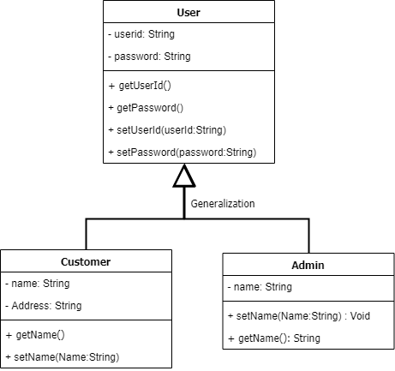

### Fig .1 : Diagram of Generalization

In this figure, we see that there are two types of users so we made a User class which will contain common properties and then we has an Customer and Admin class which are an extension of User class and will have properties of User as well as their own. Here User is the parent/superclass and the other two are child/subclass. Customer User “is-a” User as well as the Admin User.

## Association

Association is a relationship between two objects. In other words, association defines the multiplicity between objects.

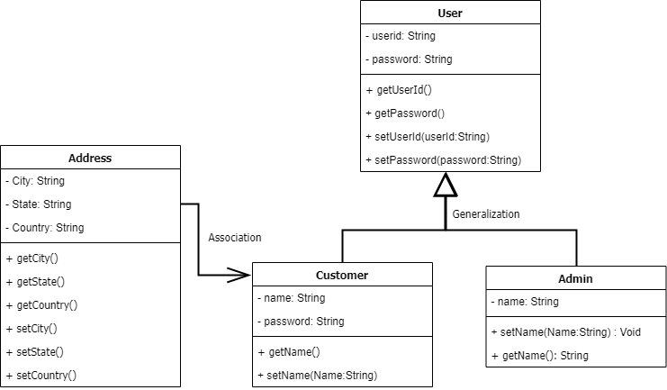

### Fig .2 : Diagram of Association

In the above figure, one Address has many numbers of Customers. Therefore the relationship between the Address and Customers is one-many. And also those two are two different entities. Therefore the relationship between the two entities is called association.